
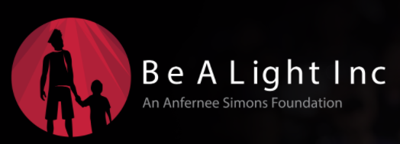

TO: High School Seniors / Post High School Graduates Ages 17-24
FROM: Be A Light, Inc An Anfernee Simons Foundation
Subject: 2026 Scholarship Opportunities
Be a light Inc, an Anfernee Simons Foundation will award 16 college scholarships and 10 trade school scholarships to deserving young adults who will or has graduated from the following counties: Seminole, Orange, Osceola, Volusia, Polk and Lake County Florida high school or an Oregon High School and attend an accredited college, university, or Trade or Vocational school program in the Fall of 2026. We will base the selection of recipients on the following criteria:
Award 16 - $2,500 Scholarships for Candidates aspiring to attend an accredited college or university:
1. A required cumulative grade point average of at least 3.0 and a combined SAT score of 900
or above or an ACT composite of 20 or above
2. 1 reference letter: From a Teacher, School Dean, School Counselor or Community Member
(church member, employer, or youth civic leader)
3. A well-written formal letter of 300 words or less based on one of the Topics below:
- How does being “a light” in difficult situations shape who you are and the way you influence others?
- What responsibility do individuals have to be a “light” in their communities, and how can small actions create meaningful change?
4. An official Transcript and copy of your SAT or ACT score results

Award 10 - $1,000 Scholarships for Candidates aspiring to attend a trade or Vocational school/program:
1. A required cumulative grade point average of at least 2.0
2. 1 reference letter: From a Teacher or Community Member (church member, employer,
or youth civic leader)
3. A well-written formal letter of 300 words or less based on one of the topics below:
- How does being “a light” in difficult situations shape who you are and the way you influence others?
- What responsibility do individuals have to be a “light” in their communities, and how can small actions create meaningful change?
4. An official Transcript
5. If a Post High School Senior, candidate can provide GED passing if applicable, along with items 1-4

The deadline for submitting all information is Tuesday, March 31, 2026. The scholarship application and all required information must come in one packet, via email to bealightscholarships@gmail.com Information received after March 31, 2026 will disqualify the applicant.
If you have any additional questions, please feel free to contact: Be A Light Inc Scholarship Committee at: bealightscholarships@gmail.com; application and the letter to the seniors/candidates are located on our website: www.be-a-light.org, under Programs > Scholarship.

